U.S. History
Standard | 3.0 Items
(2) History. The student understands traditional historical points of reference in U.S. history from 1877 to the present. The student is expected to:  (B) identify the major eras in U.S. history from 1877 to the present and describe their defining characteristics | - Identify the major eras in U.S. history from 1877 to present  - Describe the defining characteristics of the major eras in U.S. history from 1877 to present  INSERT IMAGE OF TIMELINE OF USH FROM 1877 T0 PRESENT. NO ERAS LISTED. Is an image even necessary?  Which eras did the United States experience between 1877 and 1920?  - The Great Depression and World War  - Cold War and Civil Rights  - Gilded Age and Progressive Era  - The Jazz Age and New Deal  Which era occurred in the United States prior to World War II?  - The Progressive Era  - The Great Depression  - The Gilded Age  - The New Millennium  ANS: B  Which of two eras were characterized by the following:  - laissez-faire economic policies and rising big business  - national political scandals  - new developments in transportation and infrastructure  - rising nativism and passage of laws restricting immigration  - struggles for African American political rights  - The Great Depression and Progressive Era  - The Gilded Age and Roaring Twenties  - World War II and the New Millennium  - The New Deal and Sixties
 | 2.0 Items
- Identify the major eras in U.S. history from 1877 to present
- Describe the defining characteristics of the major eras in U.S. history from 1877 to present
- Define eras characteristics
- Define economic characteristics
- Define social characteristics
- Define environment characteristics
- Define innovations characteristics

Questions

-Which of the following best characterizes the Gilded Age?
- The discovery of goldfields in the West led to more money in circulation.
- Small family-owned farms were bought and consolidated to large agricultural corporations.
- In the Deep South a sharp increase in immigration brought an increase in construction and industry.
- Industrialists used their connections with dishonest officials for material gain and political power.

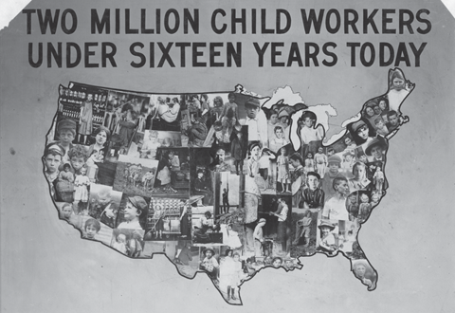

The issue addressed by this poster is primarily associated with the —
- Progressive Era
- Great Depression
- Roaring Twenties
- Cold War
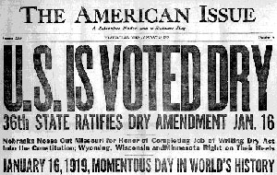
CP1

This headline from The American Issue marks the beginning of what era?
- Great Depression
- Second Industrial Revolution
- The Gilded Age
- The Roaring Twenties

ANS: D

Standard | 3.0 Items
(3) History. The student understands the political, economic, and social changes in the United States from 1877 to 1898. The student is expected to:  (A) analyze political issues such as Indian policies, the growth of political machines, civil service reform, and the beginnings of Populism | - Analyze political issues such as Indian policies  - Analyze political issues such as growth of political machines  - Analyze political issues such as civil service reform  - Analyze political issues such as beginnings of Populism  Questions:  The Populist movement was formed by small farmers. Sharecroppers, and industrial workers. What was a goal of the Populist movement in the 1890’s?  A .the adoption of the gold standard.  B. The abolition of the graduated income tax  C. the end of the secret ballot for elections  D. The nationalization of the railroad industry
 | 2.0 Items
- Analyze political issues such as Indian policies
- Analyze political issues such as growth of political machines
- Analyze political issues such as civil service reform
- Analyze political issues such as beginnings of Populism
- Summarize Indian issues
- Summarize impact of political machines
- Summarize impact of civil service reforms/acts
- Explain the cause and effects of Populism

Questions:
CP1
The primary objective of the Dawes Act was to--
A. promote cultural assimilation of American Indians
B. turn American Indian reservations into corporate farmland
C. end warfare between American Indians and the U.S. military
D. promote American Indian investment in private industry

ANS: B

What was one reason for the expansion of machine politics in the late nineteenth century?
A. The rapid influx of immigrants made it difficult for local governments to provide basic services.
B. Federal restrictions prevented voters from influencing government decisions at the local level.
C. The economy was too tightly regulated to allow urban growth.
D. Settlement houses failed to help immigrants adjust to life in the city.

During the nineteenth century, which of the following did farmers believe would help their cause?
A. the unlimited coinage of silver
B. increased mobilization
C. women’s suffrage
D. immigration quotas

CP1
First, for open, competitive examinations for testing the fitness of applicants for the public service…
Fifth, that no person in the public service is for that reason under any political fund, or to render any political service, and that he will not be removed or otherwise prejudiced for refusing to do so. --Pendleton Civil Service Act, 1883

How did the Pendleton Civil Service Act affect American politics?
A. It provided additional regulation of railroads.
B. It ended patronage in the hiring of government employees.
C. It ended campaign contributions to political candidates.
D. It required government employees to pass a drug test.
ANS: B

Standard | 3.0 Items
(3) History. The student understands the political, economic, and social changes in the United States from 1877 to 1898. The student is expected to:
(B) analyze economic issues such as industrialization, the growth of railroads, the growth of labor unions, farm issues, the cattle industry boom, the rise of entrepreneurship, free enterprise, and the pros and cons of big business

 | 2.0 Items
The railroad building boom during the nineteenth century contributed to--
A. increasing agricultural production in the Northeast.
B. the establishment of trade relations with Mexico.
C. dramatic population decreases in Southern cities.
D. the rapid industrialization of the United States.

Which statement best describes the effects of the Industrial Revolution on northern and southern states?
A. Imperialism fueled steel production in the United States.
B. New Deal policies created jobs for many of the unemployed.
C. The Sherman Antitrust Act allowed for regulation of big business.
D. Laissez-faire economic policies allowed private businesses to operate freely.

How did labor unions affect the lives of many workers during the late nineteenth century?
A. They won shorter hours and better pay for workers.
B. They helped workers take over ownership of factories and mines.
C. They worked with lawmakers to pass pro-business legislation.
D. They welcomed workers of any race or gender to join in their strikes.

CP1
The graph below shows the expansion of railroads in the United States from 1850-1900. Use your own knowledge and the graph to answer the following question. 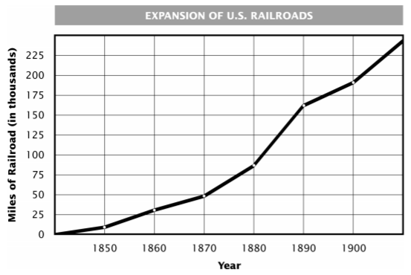
Which of these events in the 1860s had the least impact on the expansion of railroads in the United States?
- The end of the Civil War
- The industrialization of the North
- The passage of Reconstruction reforms
- The growth of cattle ranching in the West

ANS: C

Why did United States business interests favor overseas expansion in the late 1800s?
A. to establish a commonwealth of colonies
B. to establish military bases around the world
C. to acquire new markets and sources of raw materials
D. to spread democratic ideals to other areas of the world
CP1
Which factor contributed most to the rise of cities in the East between 1880 and 1900?
A. The development of inexpensive urban housing through improved construction techniques
B. Growth of industry and the spread of factories
C. A wave of immigration from South America
D. Federal highway programs helping to tie the cities together as transportation hubs
ANS: C
Why was the formation of labor unions an effect of U.S. industrialization in the late 1800s?
A. Unions were needed to guarantee a steady supply of workers
B. Union membership was required for employment in new industries
C. Factory owners set up labor unions in order to control their large workforce
D. Unions organized industrial workers to protest unsafe working conditions and long workdays

CP1
The Knights of Labor was an early labor union established during the nineteenth century.
The Knights wanted to have one union with both skilled and unskilled workers. This goal meant including African Americans, women, and selected immigrants.
Based on the above paragraph, which factor limited the effectiveness of the Knights of Labor?
- Favoring the view of management against strikers
- Demanding the reform of unpopular child labor laws
- A majority of members working to pass anti-immigration laws
- A diverse membership preventing the adoption of common demands

ANS: D
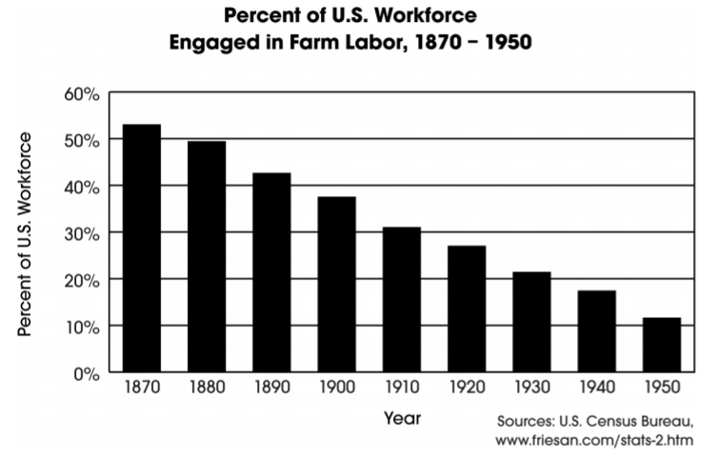
The economic development of the United States between 1870 and 1950 helped produce the results in the graph above. The trend shown in the graph is associated with
A. increased urbanization
B. decreased immigration
C. advances in communication
D. reduced population growth

Standard | 3.0 Items
(5) History. The student understands the effects of reform and third-party movements in the early 20th century. The student is expected to:  (A) evaluate the impact of Progressive Era reforms, including initiative, referendum, recall, and the passage of the 16th, 17th, 18th, and 19th amendments | - Describe initiative, referendum, and recall  - Match the 16th, 17th, 18th, and 19th amendment to meaning  - Explain the impact of any of the Progressive reforms above  - Evaluate the impact of Progressive reforms including initiative  - Evaluate the impact of Progressive reforms including referendum  - Evaluate the impact of Progressive reforms including recall  - Evaluate the impact of Progressive reforms including passage of the 16th amendment  - Evaluate the impact of Progressive reforms including passage of the 17th amendment  - Evaluate the impact of Progressive reforms including passage of the 18th amendment  - Evaluate the impact of Progressive reforms including passage of the 19th amendment  Questions:  A.  The creation of initiative, referendum, and recall procedures during the Progressive Era resulted in--  - A system a separate schools for immigrants  - The expansion of citizens’ direct participation in the democratic process  - A redistribution of the tax burden among citizens  - More sources of revenue for state governments  B.  1.16th Amendment Each state has the opportunity to vote for two of these people.  2.17th Amendment This act led to the beginning of the income tax  3.18th Amendment Brought the women’s suffrage movement into action  4. 19th Amendment This act brought the bootlegger to the forefront.  C.  Explain the impact of all terms below  ____ Initiative  ____ Referendum  ____ Recall  ____ 16th Amendment  ____ 17th Amendment  ____ 18th Amendment  ____ 19th Amendment
 | 2.0 Items
- Evaluate the impact of Progressive reforms including initiative
- Evaluate the impact of Progressive reforms including referendum
- Evaluate the impact of Progressive reforms including recall
- Evaluate the impact of Progressive reforms including passage of the 16th amendment
- Evaluate the impact of Progressive reforms including passage of the 17th amendment
- Evaluate the impact of Progressive reforms including passage of the 18th amendment
- Evaluate the impact of Progressive reforms including passage of the 19th amendment
- Define Progressive reforms
- Define initiative, referendum, and recall
- Define direct democracy
- Define 16th, 17th, 18th, and 19th amendments

Questions:
During the Progressive Era, one goal of state-level political reformers was to--
- Prevent party leaders from amending campaign platforms
- Increase the influence of business owners on regulatory legislation
- Promote the principle of direct democracy
- Limit the use of judicial review by circuit courts
CP1
The creation of intiative, referendum, and recall procedures during the Progressive Era resulted in--
- A system a separate schools for immigrants
- The expansion of citizens’ direct participation in the democratic process
- A redistribution of the tax burden among citizens
- More sources of revenue for state governments
ANS: B
READING
The Senate of the United States shall be composed of two Senators from each State, elected by the people thereof…
-17th Amendment, United States Constitution, 1913

According to the excerpt above, which of the following statements best demonstrates the constitutional change to the United States Senate?
- Senators would be chosen by a popular election rather than by state legislatures.
- Large states would no longer have more Senate representation than small states.
- Senators could no longer be impeached by the House of Representatives.
- The term of a Senator was changed to six years rather than lifetime appointment.

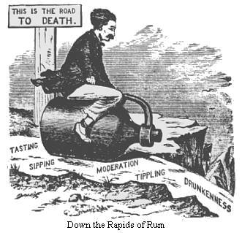
The issue addressed in this political cartoon was later settled by--
- The ratification of the Eighteenth Amendment
- The creation of the Dawes Act
- The initiation of Westward Expansion
- The unlimited coinage of silver
ANS: A
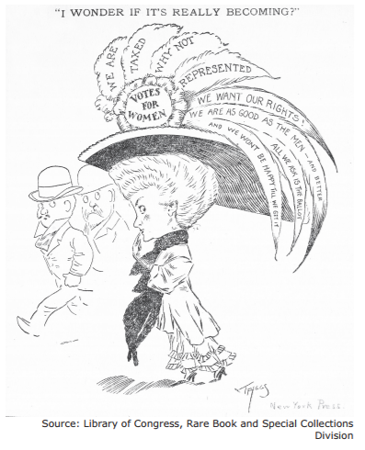
The issue addressed in this political cartoon was later settled by--
- The creation of the Temperance Society
- The repeal of the Eighteenth Amendment
- The initiation of the Settlement House movement
- The ratification of the Nineteenth Amendment

Standard | 3.0 Items
(5) History. The student understands the effects of reform and third-party movements in the early 20th century. The student is expected to:
(B) evaluate the impact of muckrakers and reform leaders such as Upton Sinclair, Susan B. Anthony, Ida B. Wells, and W. E. B. DuBois on American society

 | 2.0 Items
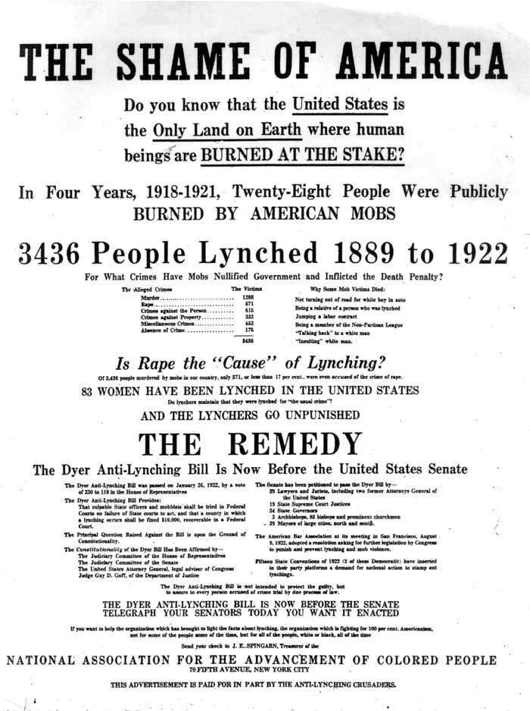

Which individual was devoted to reforms that would remedy the problem illustrated above?

- Upton Sinclair
- Ida B. Wells
- Ida Tarbell
- Lincoln Steffens

Ans: B
29H

Standard | 3.0 Items
(9) History. The student understands the impact of the American civil rights movement. The student is expected to:
(A) trace the historical development of the civil rights movement in the 19th, 20th, and 21st centuries, including the 13th, 14th, 15th, and 19th amendments

 | 2.0 Items
CP1
READING:
Section 1.
All persons born or naturalized in the United States, and subject to the jurisdiction thereof, are citizens of the United States and of the state wherein they reside. No state shall make or enforce any law which shall abridge the privileges or immunities of citizens of the United States; nor shall any state deprive any person of life, liberty, or property, without due process of law; nor deny to any person within its jurisdiction the equal protection of the laws.
-Fourteenth Amendment, 1868

How did the Fourteenth Amendment affect the American legal system?
A. It required that laws be applied equally to all citizens.
B. It granted citizenship to all residents of the United States.
C. It ensured that a state could not take a citizen’s personal property.
D. It extended the concept of community standards to state laws.
Answer: A

How did the end of the U.S. Civil War affect American politics?
A. Legislation passed that supported property rights and due process for women.
B. Legislation passed that established voting rights for American Indians.
C. Legislation passed that provided citizenship and legal protections for freed slaves.
D. Legislation passed that enhanced individual states’ rights.

The 13th, 14th, and 15th Amendments to the Constitution of the United States were intended to solve problems relating to
A. government organizations.
B. civil rights.
C. checks and balances.
D. rapid economic change.

Standard | 3.0 Items
(13) Geography. The student understands the causes and effects of migration and immigration on American society. The student is expected to:
(A) analyze the causes and effects of changing demographic patterns resulting from migration within the United States, including western expansion, rural to urban, the Great Migration, and the Rust Belt to the Sun Belt

 | 2.0 Items
CP1 **Could put two maps (1 of native land, 1 of railroads)
One effect railroads had on Native Americans living in the western United States was the--
- Eastern migration of most western Native American tribes.
- Gradual improvement of the Native Americans’ standard of living
- Eventual destruction of the Native Americans’ way of life
- Compete incorporation of Native Americans into United States society.
Answer: C

CP1
The graph below shows the number of farms in the United States in 1860 and 1910.
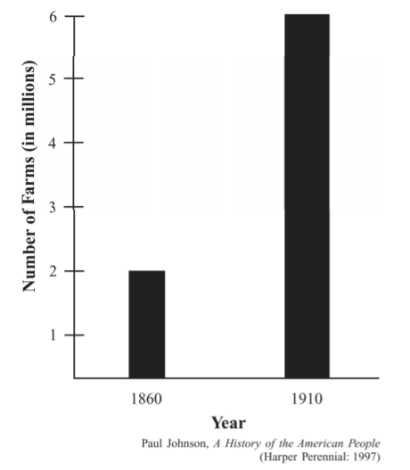
How did the Homestead Act of 1862 contribute to the changes shown on the graph?
- The government provided land to settlers in the West.
- The government gave funds to railroad companies in the West.
- The government funded large-scale irrigation projects in the West.
- The government promised to buy cash crops from farmers in the West.
Answer: A

Standard | 3.0 Items
(13) Geography. The student understands the causes and effects of migration and immigration on American society. The student is expected to:
(B) analyze the causes and effects of changing demographic patterns resulting from legal and illegal immigration to the United States.

 | 2.0 Items
CP1
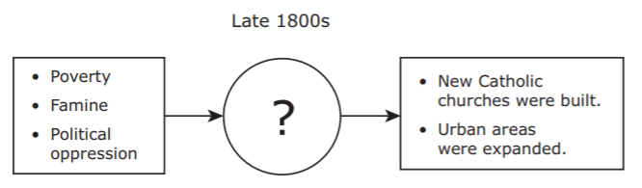

Which sentence correctly completes this diagram?
A. The Bracero program was introduced.
B. The Chinese Exclusion Act was passed.
C. Russian radicals joined labor unions in the United States.
D. Irish families immigrated to the United States.

Answer: D

Standard | 3.0 Items
(15) Economics. The student understands domestic and foreign issues related to U.S. economic growth from the 1870s to 1920. The student is expected to:
(B) describe the changing relationship between the federal government and private business, including the costs and benefits of laissez-faire, anti-trust acts, the Interstate Commerce Act, and the Pure Food and Drug Act

 | 2.0 Items
CP1
How did government policies of the Gilded Age of the late 1800s promote industrialization?
- Imperialism fueled steel production in the United States.
- New Deal policies created jobs for many of the unemployed.
- The Sherman Antitrust Act allowed for regulation of big business.
- Laissez-faire economic policies allowed private businesses to operate freely.
Answer: D
**are the answer choices confusing?

CP1
In the 1880s, popular concern about railroad abuses such as price fixing, kickbacks, and unfair freight rates led to the passing of the Interstate Commerce Act. Which of the following best describes the impact of this legislation?
- Government involved in private business.
- Labor strikes for higher wages
- Government control over hiring
- Riots for better working conditions
Answer: A

Standard | 3.0 Items
(26) Culture. The student understands how people from various groups contribute to our national identity. The student is expected to:
(A) explain actions taken by people to expand
economic opportunities and political rights, including those for racial, ethnic, and religious minorities as well as women, in American society

 | 2.0 Items
CP1
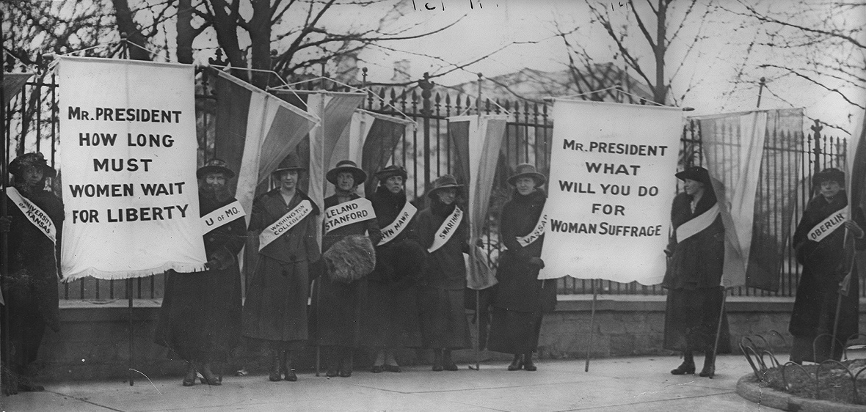

How did the actions above expand political rights?
- By promoting military service through the Selective Service Act
- By filing legal cases to overturn segregation
- By organizing an economic boycott for working conditions
- By ratifying the Nineteenth Amendment

Answer: D

How did Chavez accomplish the change referred to in this excerpt?

A By promoting military service as an opportunity for minority youths

B By filing legal cases to overturn segregation in public facilities

C By organizing an economic boycott to improve working conditions for migrant farmers

D By protesting fines imposed on employers for hiring illegal immigrants

Standard | 3.0 Items
(27) Science, technology, and society. The student understands the impact of science, technology, and the free enterprise system on the economic development of the United States. The student is expected to:
(A) explain the effects of scientific discoveries and technological innovations such as electric power, telephone and satellite communications, petroleum-based products, steel production, and computers on the economic development of the United States

 | 2.0 Items
CP1
How has the development of satellite technology affected the U.S. economy?
- By resulting in increased private funding of research institutions.
- By increasing efficiency in telecommunications
- By enabling transoceanic air travel
- By facilitating the development of technologies that improve fuel efficiency
Answer: B

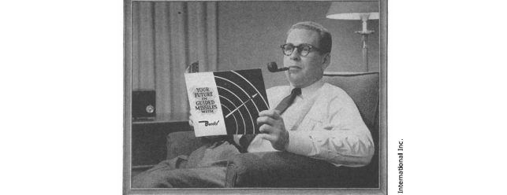
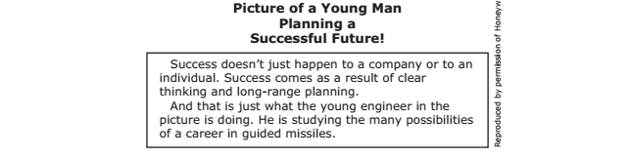

Jobs such as the ones described in this 1956 advertisement became available because--
- Federal law required private business to recruit for the military
- Weak college programs had produced few scientists qualified for high-level research
- Cold War defense programs had spurred technological innovation
- Most U.S. citizens opposed the development of atomic weapons

